Steps to Health Travel Reimbursement Procedure
All travel reimbursed through Steps to Health requires documentation according to NC State University and NC Department of Health & Human Services policies.

NC State Employees Requesting Personal Reimbursement
- All NC State Employees will be responsible for submitting their own Travel Reimbursement within MyPack Portal.
  - In order to be reimbursed, Travel Reimbursement request(s) must be submitted within 30 days of the first date of travel.
  - The project phase ID/funding center must be included in the comments section of the TR. (583172-10374). Also in the comments section request Jayne McBurney (jmcbill) be included in the workflow as an approver.
- All individuals traveling with the support of Steps to Health funds are required to create detailed travel documentation using the provided Excel travel log template.
  - The template can be accessed at www.ncstepstohealth.ces.ncsu.edu/. On the left menu scroll to “Agent Resources” and click on “Administrative Forms”. You will see the “Travel Log” file that you can download and save to your computer.
- Within the excel workbook, each TR needs its own sheet/tab.
- To complete the travel log follow these steps:
- Fill in the trip ID. This is the TR number that is generated in MyPack portal after you saved and/or submit the TR.
- Fill in the name of the County in which the program was conducted.
- Fill in Program Name
- Fill in your name (the traveler)
- Record the trip number. A trip counts as the travel that occurs between leaving and returning to your duty station. Each leg of that trip (one destination to the next) should be recorded on a separate line, but have the same “trip #). For example:
    - Trip 1 1/1/15 Office to School ABC 5 miles
    - Trip 1 1/1/15 School ABC to the office 5 miles
    - Trip 2 1/2/15 Office to store 2 miles
    - Trip 2 1/2/15 Store to office 2 miles
- Record the travel date
- Record the name of the starting location
- Record the address of the starting location
- Record the name of the ending location
- Record the address of the ending location
- Record the number of miles for each line of travel or leg of the trip. All miles should be recorded as they appear in the TR, rounded to the nearest whole number. See Example 2 on pg. 5
- If daily travel exceeds 100 miles reference the NCSU website/TR rate tab for reimbursement rate information. See Example 3 on pg. 6
- After all of the legs of each Trip# are listed, add up the total miles (this should match the TR) See example 2&3
- Record the rate paid for each trip. Please check for rate changes on the NCSU website. Rates for State and County vehicles will vary. See Example 3 on pg. 6
- Record the total dollar amount for the trip in the cell to the right of the rate amount. This should match the total the TR. See Example 3 on pg. 6
- Each document should be formatted to print landscape flowing down to the next page. The travel log should only be one page wide and not overflow to the right. There should not be any information to the right of the page break line.
  - To set the page orientation: From the excel menu bar click on “File ➔page setup ➔ page ➔ click on the landscape button ➔ click on OK. See Example 4 &5 on pg. 8-9.
  - If your version of excel allows, label the tab with the TR#
  - Save the document
  - To upload the file you’ve created into the TR in MyPack Portal, the document must also be saved as one of the following formats: .pdf, .jpg or .tff. See example 6 on pg. 10
  - From the Excel menu bar click on “File ➔ Save As ➔ Click on the “Format” drop down window ➔ Select one of the following formats .pdf, .jpg, .tff ➔ In the Save As field at the top of the dialog box type in the name of the file ➔ click on okay
  - Go back to the TR in MyPack Portal, upload the document in section 3

Counties Requesting Reimbursement for Use of State Vehicles
- In order to receive reimbursement, counties should submit the State Vehicle Mileage Log (SVML) to CALS Business Center for processing. The SVML should clearly identify the county, agent, and program (2nd, 3rd, CMH, etc.) and project ID and phase number (583172-10374).
- A copy of the log must also be scanned and emailed or mailed to the STH office.
  - Send the SVML in on a monthly basis
- The excel travel log must also accompany the SVML
  - The template can be accessed at www.ncstepstohealth.ces.ncsu.edu/. On the left menu scroll to “Agent Resources” and click on “Administrative Forms”. You will see the “Travel Log” file that you can download and save to your computer.
- See NC State Employees Requesting Personal Reimbursement, beginning Step 2 for further instructions on completing this form.
- The following fields can remain blank
  - Voucher ID
  - Trip ID(TR)

Non-NC State Employees
- Complete the online form(s) and paperwork (W-9 & ACH) found in My Pack Portal. An Administrative Professional/Colleague in your office can assist you with accessing NC State’s My Pack Portal supplier entry process. Once completed a supplier number will be issued.
  - An invoice can be created using the Blank Invoice template found in the Agent Resources section of the STH website. Include the supplier number issued and the address as it was entered in My Pack Portal.
- All individuals traveling with the support of Steps to Health funds are required to create detailed travel documentation using the provided Excel travel log template.
- The template can be accessed at www.ncstepstohealth.ces.ncsu.edu/. On the left menu scroll to “Agent Resources” and click on “Administrative Forms”. You will see the “Travel Log” file that you can download and save to your computer.
- To complete the travel log follow these steps:
- Fill in the trip ID. This is the TR number that is generated in MyPack portal after you saved and/or submit the TR.
- Fill in the name of the County in which the program was conducted.
- Fill in Program Name
- Fill in your name (the traveler)
- Record the trip number. A trip counts as the travel that occurs between leaving and returning to your duty station. Each leg of that trip (one destination to the next) should be recorded on a separate line, but have the same “trip #). For example:
    - Trip 1 1/1/15 Office to School ABC 5 miles
    - Trip 1 1/1/15 School ABC to the office 5 miles
    - Trip 2 1/2/15 Office to store 2 miles
    - Trip 2 1/2/15 Store to office 2 miles
- Record the travel date
- Record the name of the starting location
- Record the address of the starting location
- Record the name of the ending location
- Record the address of the ending location
- Record the number of miles for each line of travel or leg of the trip. All miles should be rounded to the nearest whole number.
- If daily travel exceeds 100 miles reference the NCSU website for reimbursement rate information.
- After all of the legs of each Trip# are listed, add up the total miles
- Record the rate paid for each trip. Rates for State and County vehicles will vary. See Example 4 on pg. 7.
- Record the total dollar amount for the trip in the cell to the right of the rate amount. See Example 4 on pg. 7.
- Each document should be formatted to print landscape flowing down to the next page. The travel log should only be one page wide and not overflow to the right. There should not be any information to the right of the page break line.
  - To set the page orientation: From the excel menu bar click on “File ➔page setup ➔ page ➔ click on the landscape button ➔ click on OK. See Example 4 &5 on pg. 8-9.
  - If your version of excel allows, label the tab with the TR#
  - Save the document
  - To upload the file you’ve created into the TR in MyPack Portal, the document must also be saved as one of the following formats: .pdf, .jpg or .tff. See example 6 on pg. 10
  - From the Excel menu bar click on “File ➔ Save As ➔ Click on the “Format” drop down window ➔ Select one of the following formats .pdf, .jpg, .tff ➔ In the Save As field at the top of the dialog box type in the name of the file ➔ click on okay
  - Go back to the TR in MyPack Portal, upload the document in section 3

Example 1: TR number and Voucher ID number location
Initially the TR number and Voucher ID will appear as “NEXT”
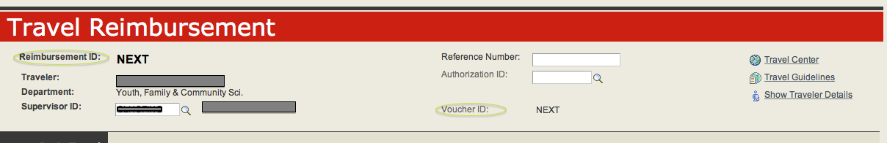

Once the “Saved” and “Submit for Approval” buttons are clicked the TR number is assigned
Voucher number assigned after the TR is approved for payment
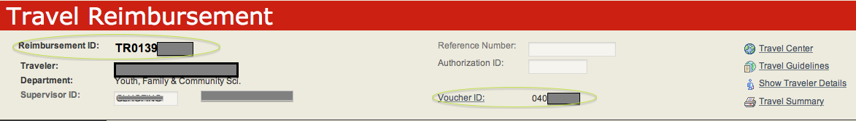

TR number and Voucher ID number can also be found on the main screen of Travel Center within My Pack Portal
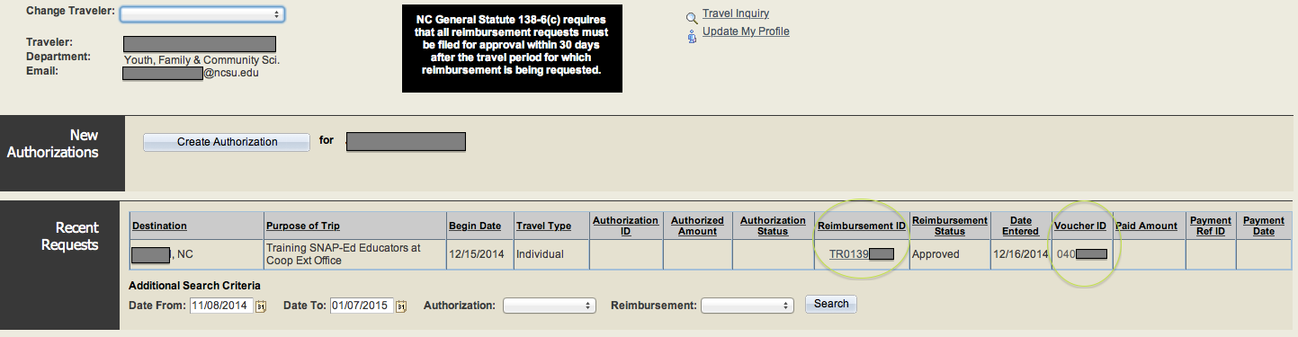

Example 2: Mileage Total

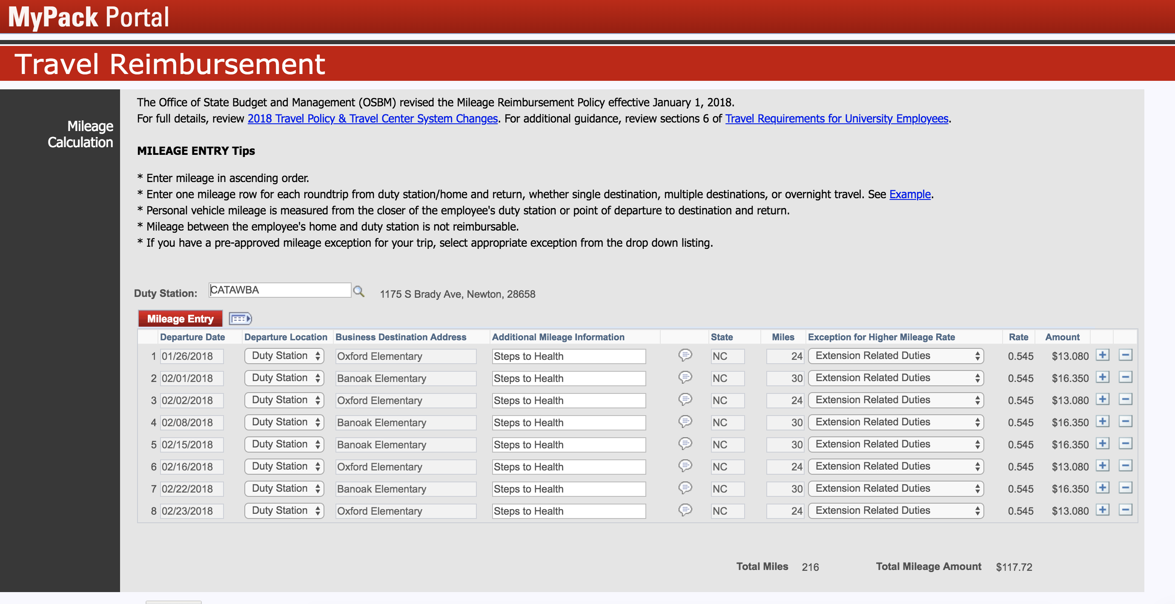

Example 3: Reimbursement Rate

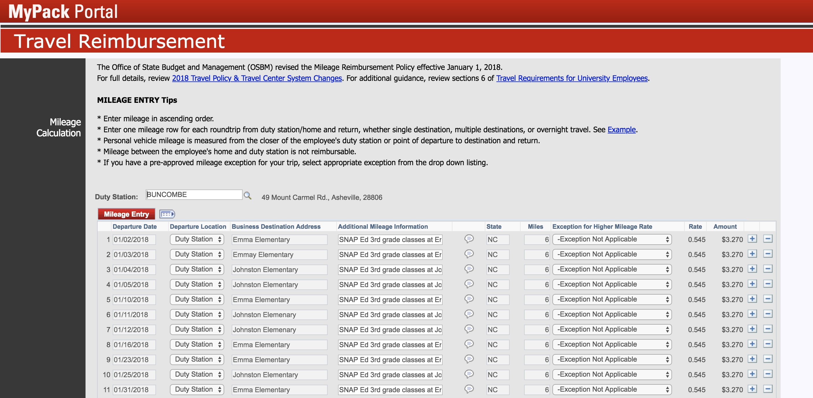

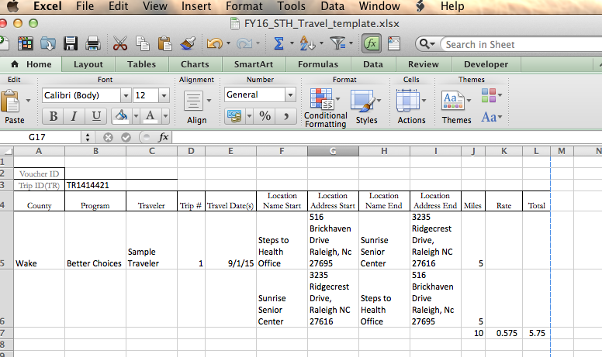

Example 4: PAGE ORIENTATION

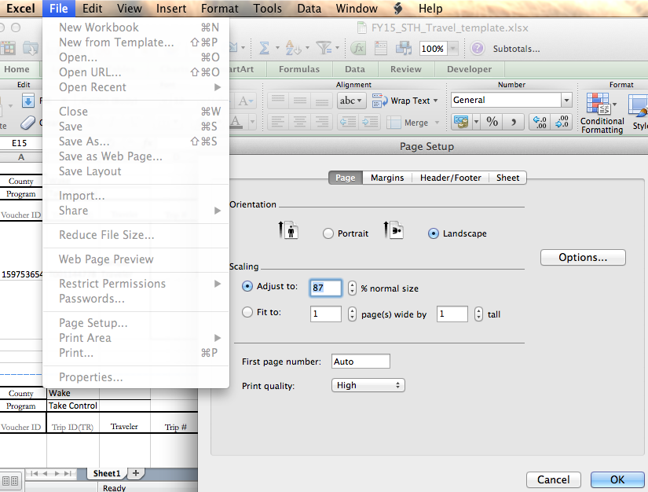

Example 5: PAGE BREAK

Example 6: Save in alternate format (.pdf, .jpg, .tff)