Untitled:Users:lnhecht:Desktop:MyDocuments:NCSU Grant:S2H 08-09:Final0809Training:LOGOS:StepsToHealthLogo(5)-1.pdf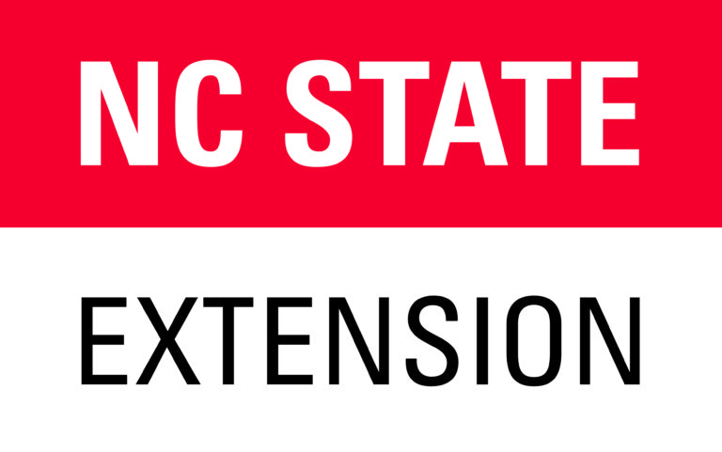

Date:

From:

(Manager/Director Name)

Site Name:

Address:

To: SNAP-Ed Steps to Health

516 Brickhaven Drive

Raleigh, North Carolina 27695

Dear SNAP-Ed Steps to Health,

We invite the NC State Extension Agent/Associate in ___________ County to deliver the Color Me Healthy for SNAP-Ed Program as outlined in the program curriculum (9 weekly sessions) to the 4 and 5 year olds at our site.

________ percentage of children here are receiving a reduced or free meal through the Child and Adult Care Food Program or attend our site through subsidized payment.

Sincerely,

(Signature)

(Name)