xxxxx

**Spicy Steps to Health Seasoning**

1 Tablespoon garlic powder

1 teaspoon onion powder

½ teaspoon cayenne powder

1 teaspoon black pepper

1 teaspoon basil

1 teaspoon sage

½ teaspoon thyme

¼ teaspoon salt (optional)

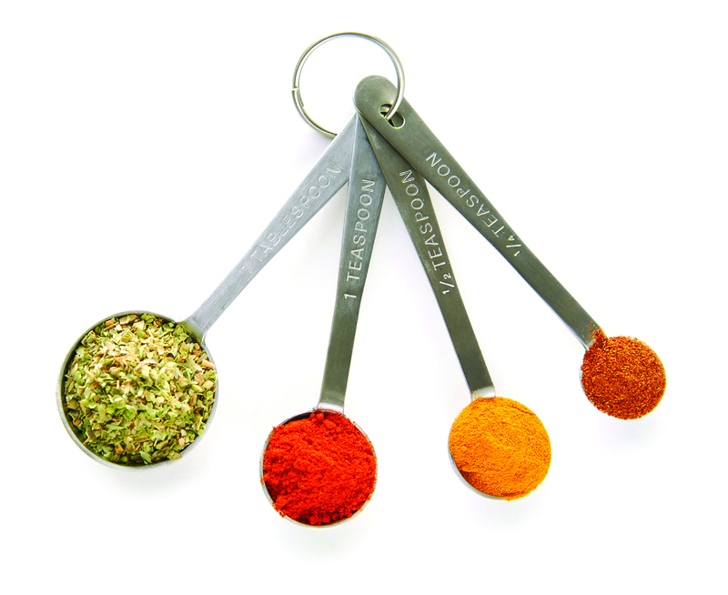



**Spicy Steps to Health Seasoning**

1 Tablespoon garlic powder

1 teaspoon onion powder

½ teaspoon cayenne powder

1 teaspoon black pepper

1 teaspoon basil

1 teaspoon sage

½ teaspoon thyme

¼ teaspoon salt (optional)

**SOURCE:**

**SOURCE:**