xxxxx

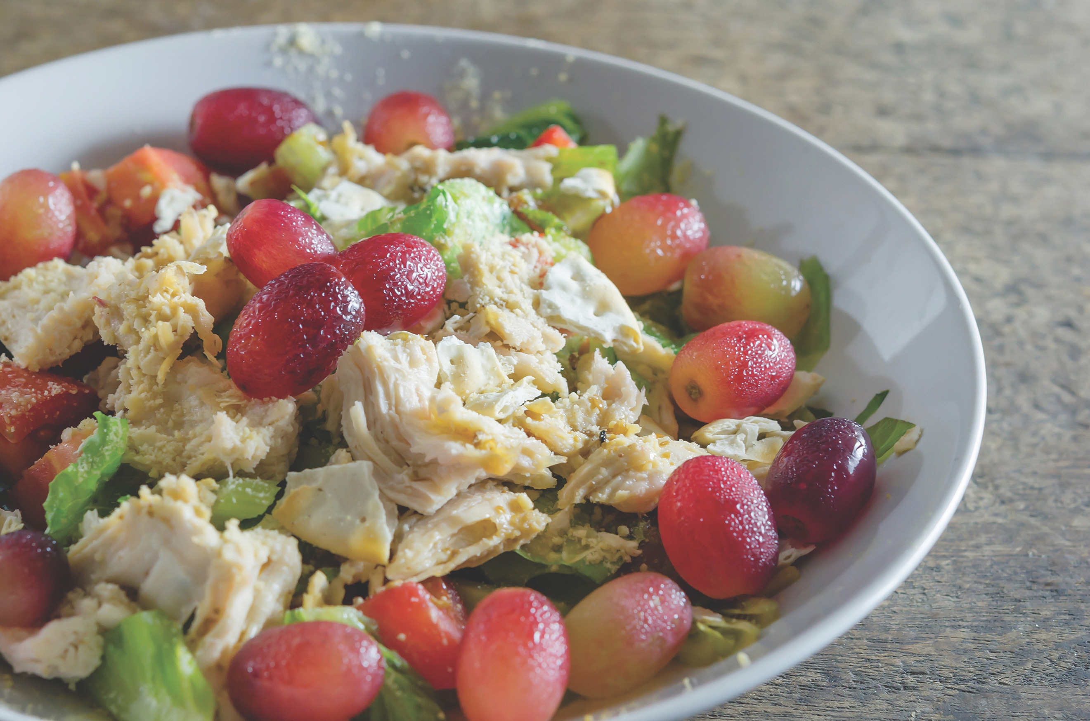

**Chicken and Fruit Salad**

Makes 8 Servings

Serving Size: 2/3 cup

Ingredients:

* 3 cups cooked chicken, chopped
* 1 (20 – ounce) can pineapple chunks in juice, drained well
* 1 (11-ounce) can mandarin oranges, in 100% fruit juice, drained
* 3/4 cup chopped celery
* 1 cup halved seedless grapes
* 1/4 cup low-fat mayonnaise
* 1/4 teaspoon black pepper
* 8 large lettuce leaves

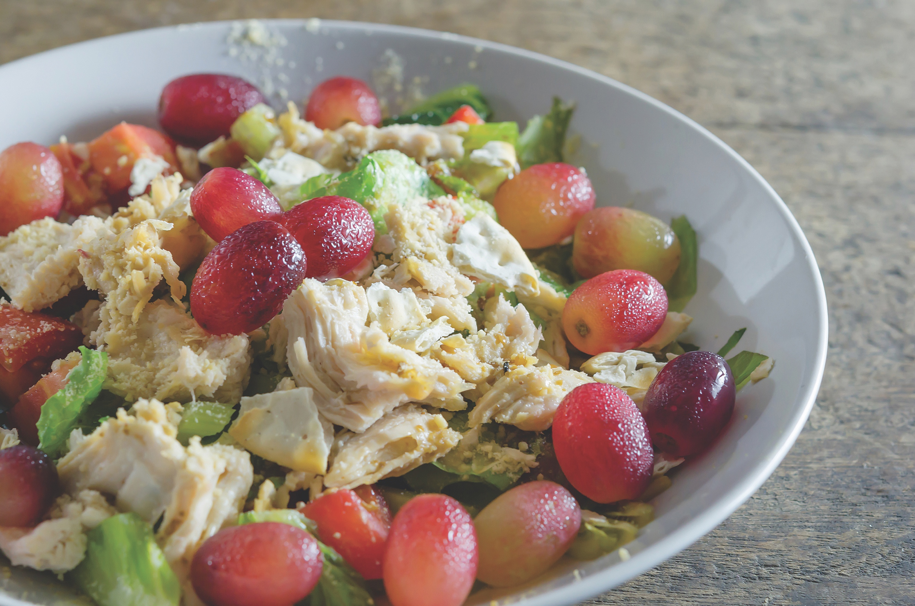

Directions:

1. in a large bowl, mix gently chicken, pineapple chunks, oranges, celery, and grapes.
2. In a separate bowl, mix low-fat mayonnaise and black pepper.
3. Gently stir mayonnaise into chicken mixture,
4. Cover, and chill in the refrigerator.
5. To serve, scoop 2/3 cup of chicken salad onto a lettuce leaf.

Directions:

1. in a large bowl, mix gently chicken, pineapple chunks, oranges, celery, and grapes.
2. In a separate bowl, mix low-fat mayonnaise and black pepper.
3. Gently stir mayonnaise into chicken mixture,
4. Cover, and chill in the refrigerator.
5. To serve, scoop 2/3 cup of chicken salad onto a lettuce leaf.

**Chicken and Fruit Salad**

Makes 8 Servings

Serving Size: 2/3 cup

Ingredients:

* 3 cups cooked chicken, chopped
* 1 (20 – ounce) can pineapple chunks in juice, drained well
* 1 (11-ounce) can mandarin oranges, in 100% fruit juice, drained
* 3/4 cup chopped celery
* 1 cup halved seedless grapes
* 1/4 cup low-fat mayonnaise
* 1/4 teaspoon black pepper
* 8 large lettuce leaves

**SOURCE:**

**SOURCE:**