xxxxx

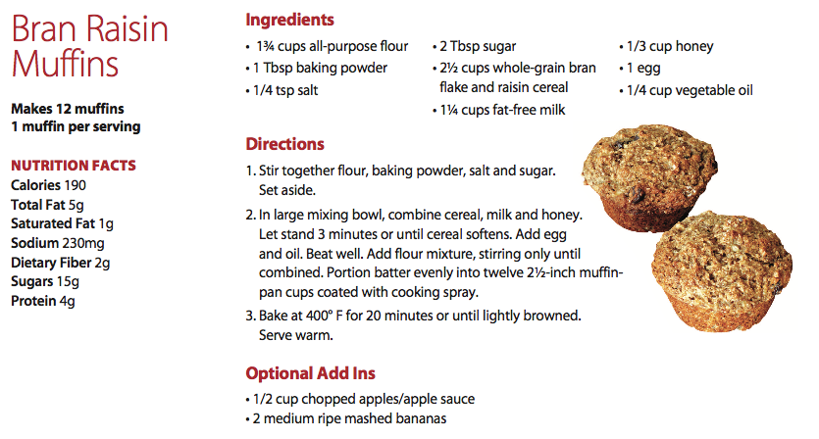

**SOURCE:**

