What is Steps to Health?
Steps to Health is NC State University’s SNAP-Ed program through NC Cooperative Extension.
What is SNAP-Ed?
The Supplemental Nutrition Program – Education (SNAP-Ed) serves limited resource families across NC. SNAP-Ed is funded by the United States Department of Agriculture through the NC Department of Health and Human Services, Division of Social Services.
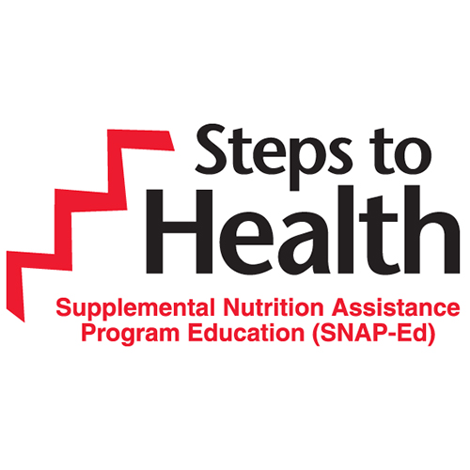
make half your plate
fruits and vegetables

Sweet Potatoes
- High in Vitamin A
- Good Source of Vitamin C
- Good Source of Fiber

Home Grown Facts about Sweet Potatoes
- Official state vegetable of NC
- NC is the top grower of sweet potatoes
- Hundreds of varieties

Tell us if you liked it!

Take a free Recipe and Tips Sheets!
Try a Sweet Potato Fry!

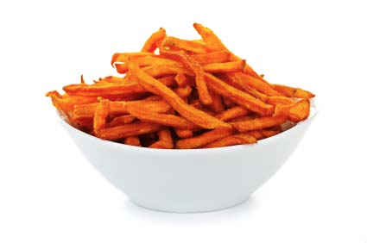
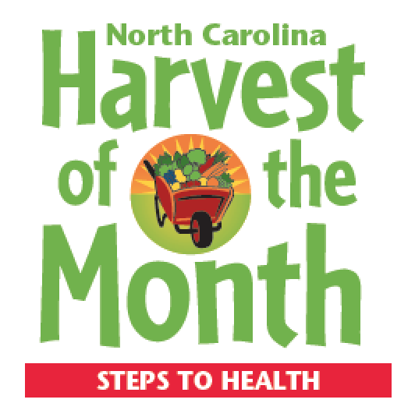
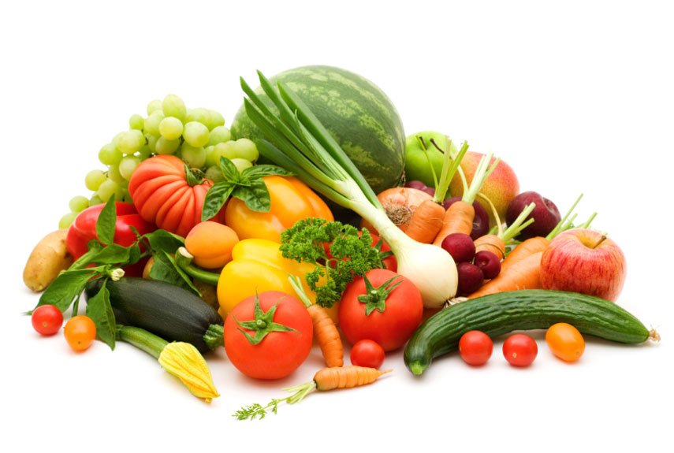
Sample a
Strawberry Splits with Low Fat Yogurt & Granola:
- High in Vitamin C
- High in Calcium and Vitamin D
- Good Source of Vitamin A
- Source of Fiber

Try a Strawberry Split!

Strawberry Splits are healthy & great for:
- Breakfast
- Snack
- Dessert

Tell us if you liked it!

Take a free Recipe and Tips Sheets!
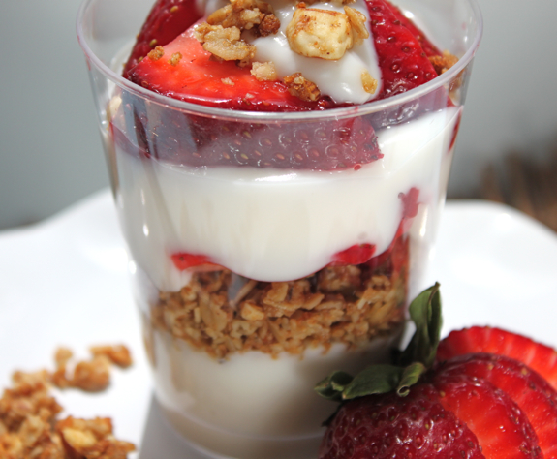
Try a sample of :

Take one,
Recipe inside

Try a Peach Parfait!
Take a Recipes & Tip Sheet
Peaches are:
- Low fat
- High in Vitamin C
- High in Vitamin A
- High in Fiber

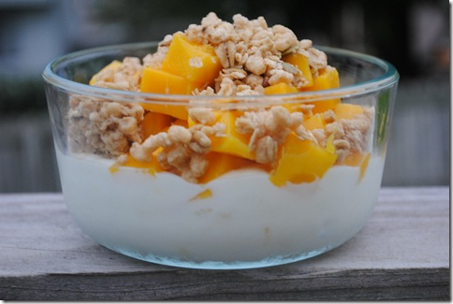

Buying fruits and vegetables in season can help you save money.

When do I grow?
Test your seasonality knowledge. Match the fruits and vegetables with the month in which they grow in North Carolina!

Aug – Feb May – June

July July – Aug

Sept – Oct Year Round

June – July March – April
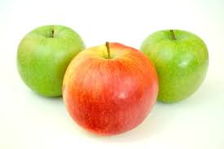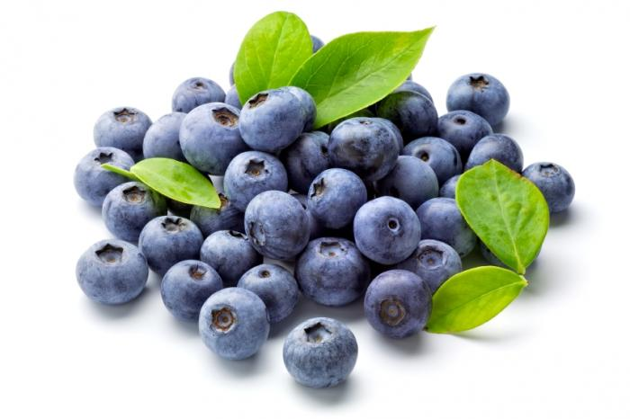

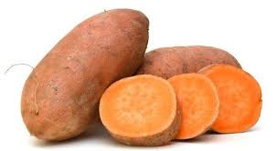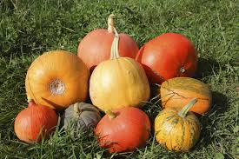
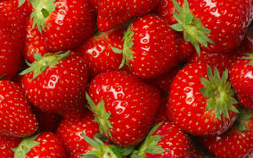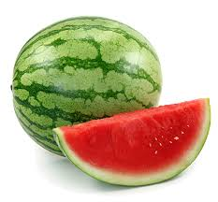

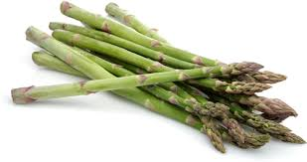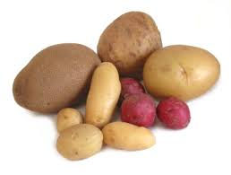

Apples are in Season!

Family Fun Apple Activities:

- Pick-your-own apples at an orchard
- Make an apple recipe together
- Try different types of apples
Youth Color Contest:
On the coloring page, draw how these in-season fruits and vegetables grow:
- apples
- blackberries
- pumpkins
- sweet potatoes
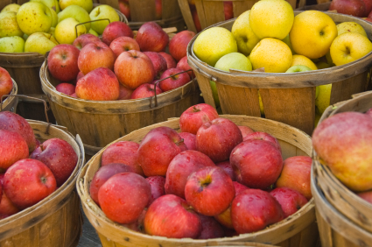

Apples contain:
- No fat
- Vitamin C
- High in Fiber

Try these apples:
Mutzu
Saylor Sunrise
Golden delicious

Try these apples:
Fuji
Pink Lady
Gold Rush

