xxxxx

**Herb Dip**

Ingredients:

* 1 cup cottage cheese, low-fat
* 4 tablespoons yogurt, low-fat plain (1/4 cup)
* 1 tablespoon onion (chopped, or chives)
* 1 teaspoon parsley (dried)
* 1/4 teaspoon dill (dried)

Directions

* 1. Place all the ingredients in a blender.
* 2. Blend all the ingredients thoroughly.
* 3. Pour the mixture into a clean container.
* 4. Cover and chill.

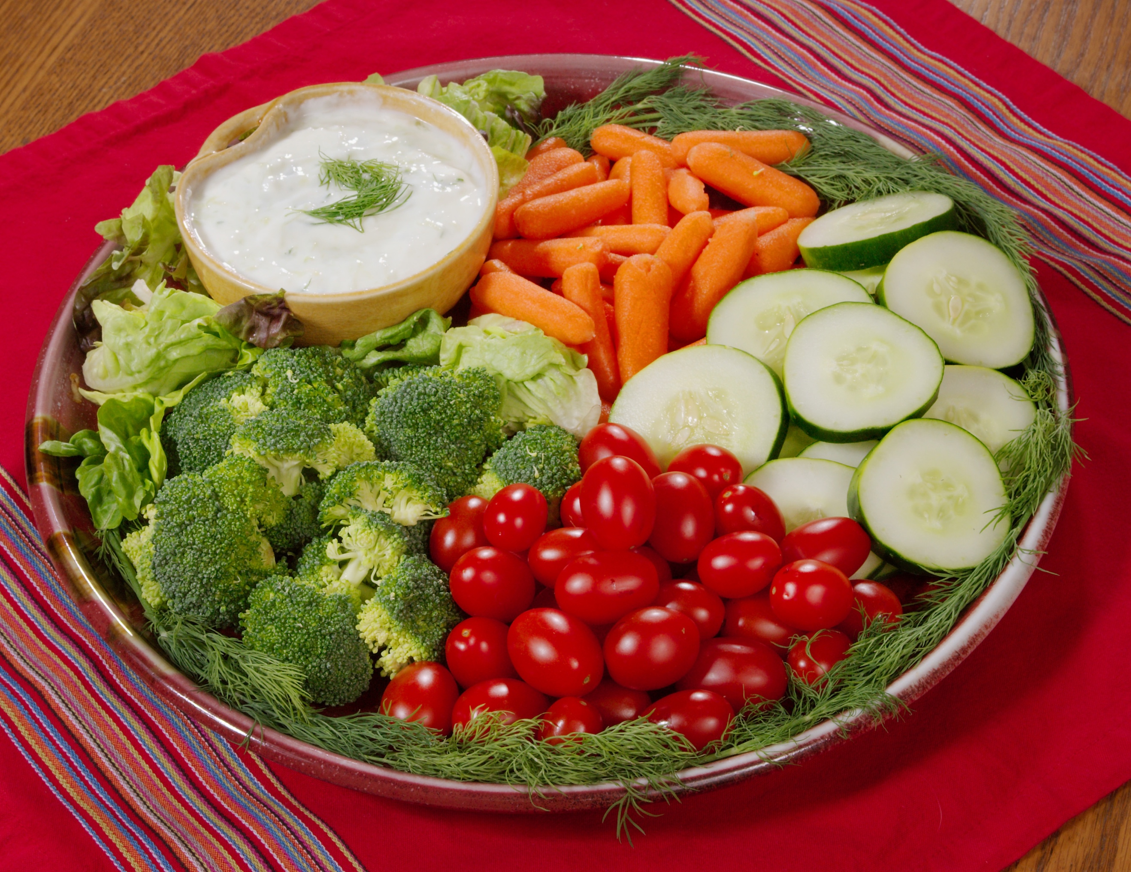



**Herb Dip**

Ingredients:

* 1 cup cottage cheese, low-fat
* 4 tablespoons yogurt, low-fat plain (1/4 cup)
* 1 tablespoon onion (chopped, or chives)
* 1 teaspoon parsley (dried)
* 1/4 teaspoon dill (dried)

Directions

* 1. Place all the ingredients in a blender.
* 2. Blend all the ingredients thoroughly.
* 3. Pour the mixture into a clean container.
* 4. Cover and chill.